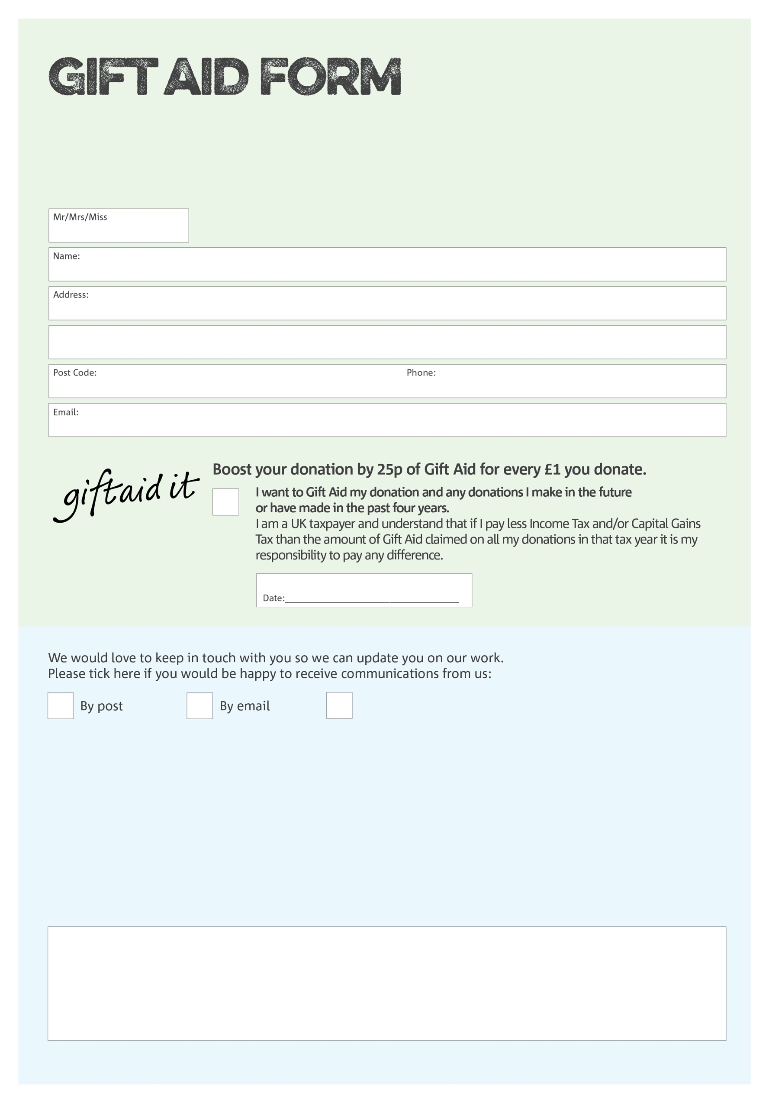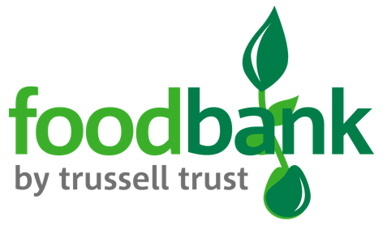

By filling in this form Wrexham Foodbank will receive an extra 25p for every £1 you give at no extra cost to you. Thank you!

**Data protection**

*'Wrexham Foodbank is committed to protecting your privacy and will process your personal data in accordance with current Data Protection legislation. Wrexham Foodbank collects information to keep in touch with you and supply you with information relating to our work. To unsubscribe from our newsletter, send a message to the email address above with the word unsubscribe in the subject line. A full data privacy statement for financial donors is available from the foodbank on request.’*

We would love to know why you have chosen to donate to Wrexham Foodbank. If you would like to share your motivation let us know below:

I do not wish to receive future communications from Wrexham Foodbank

You can change your preferences any time by contacting us on 07538547971 or emailing us at

info@wrexham.foodbank.org.uk

Charity Number 1162262. Registered in England & Wales