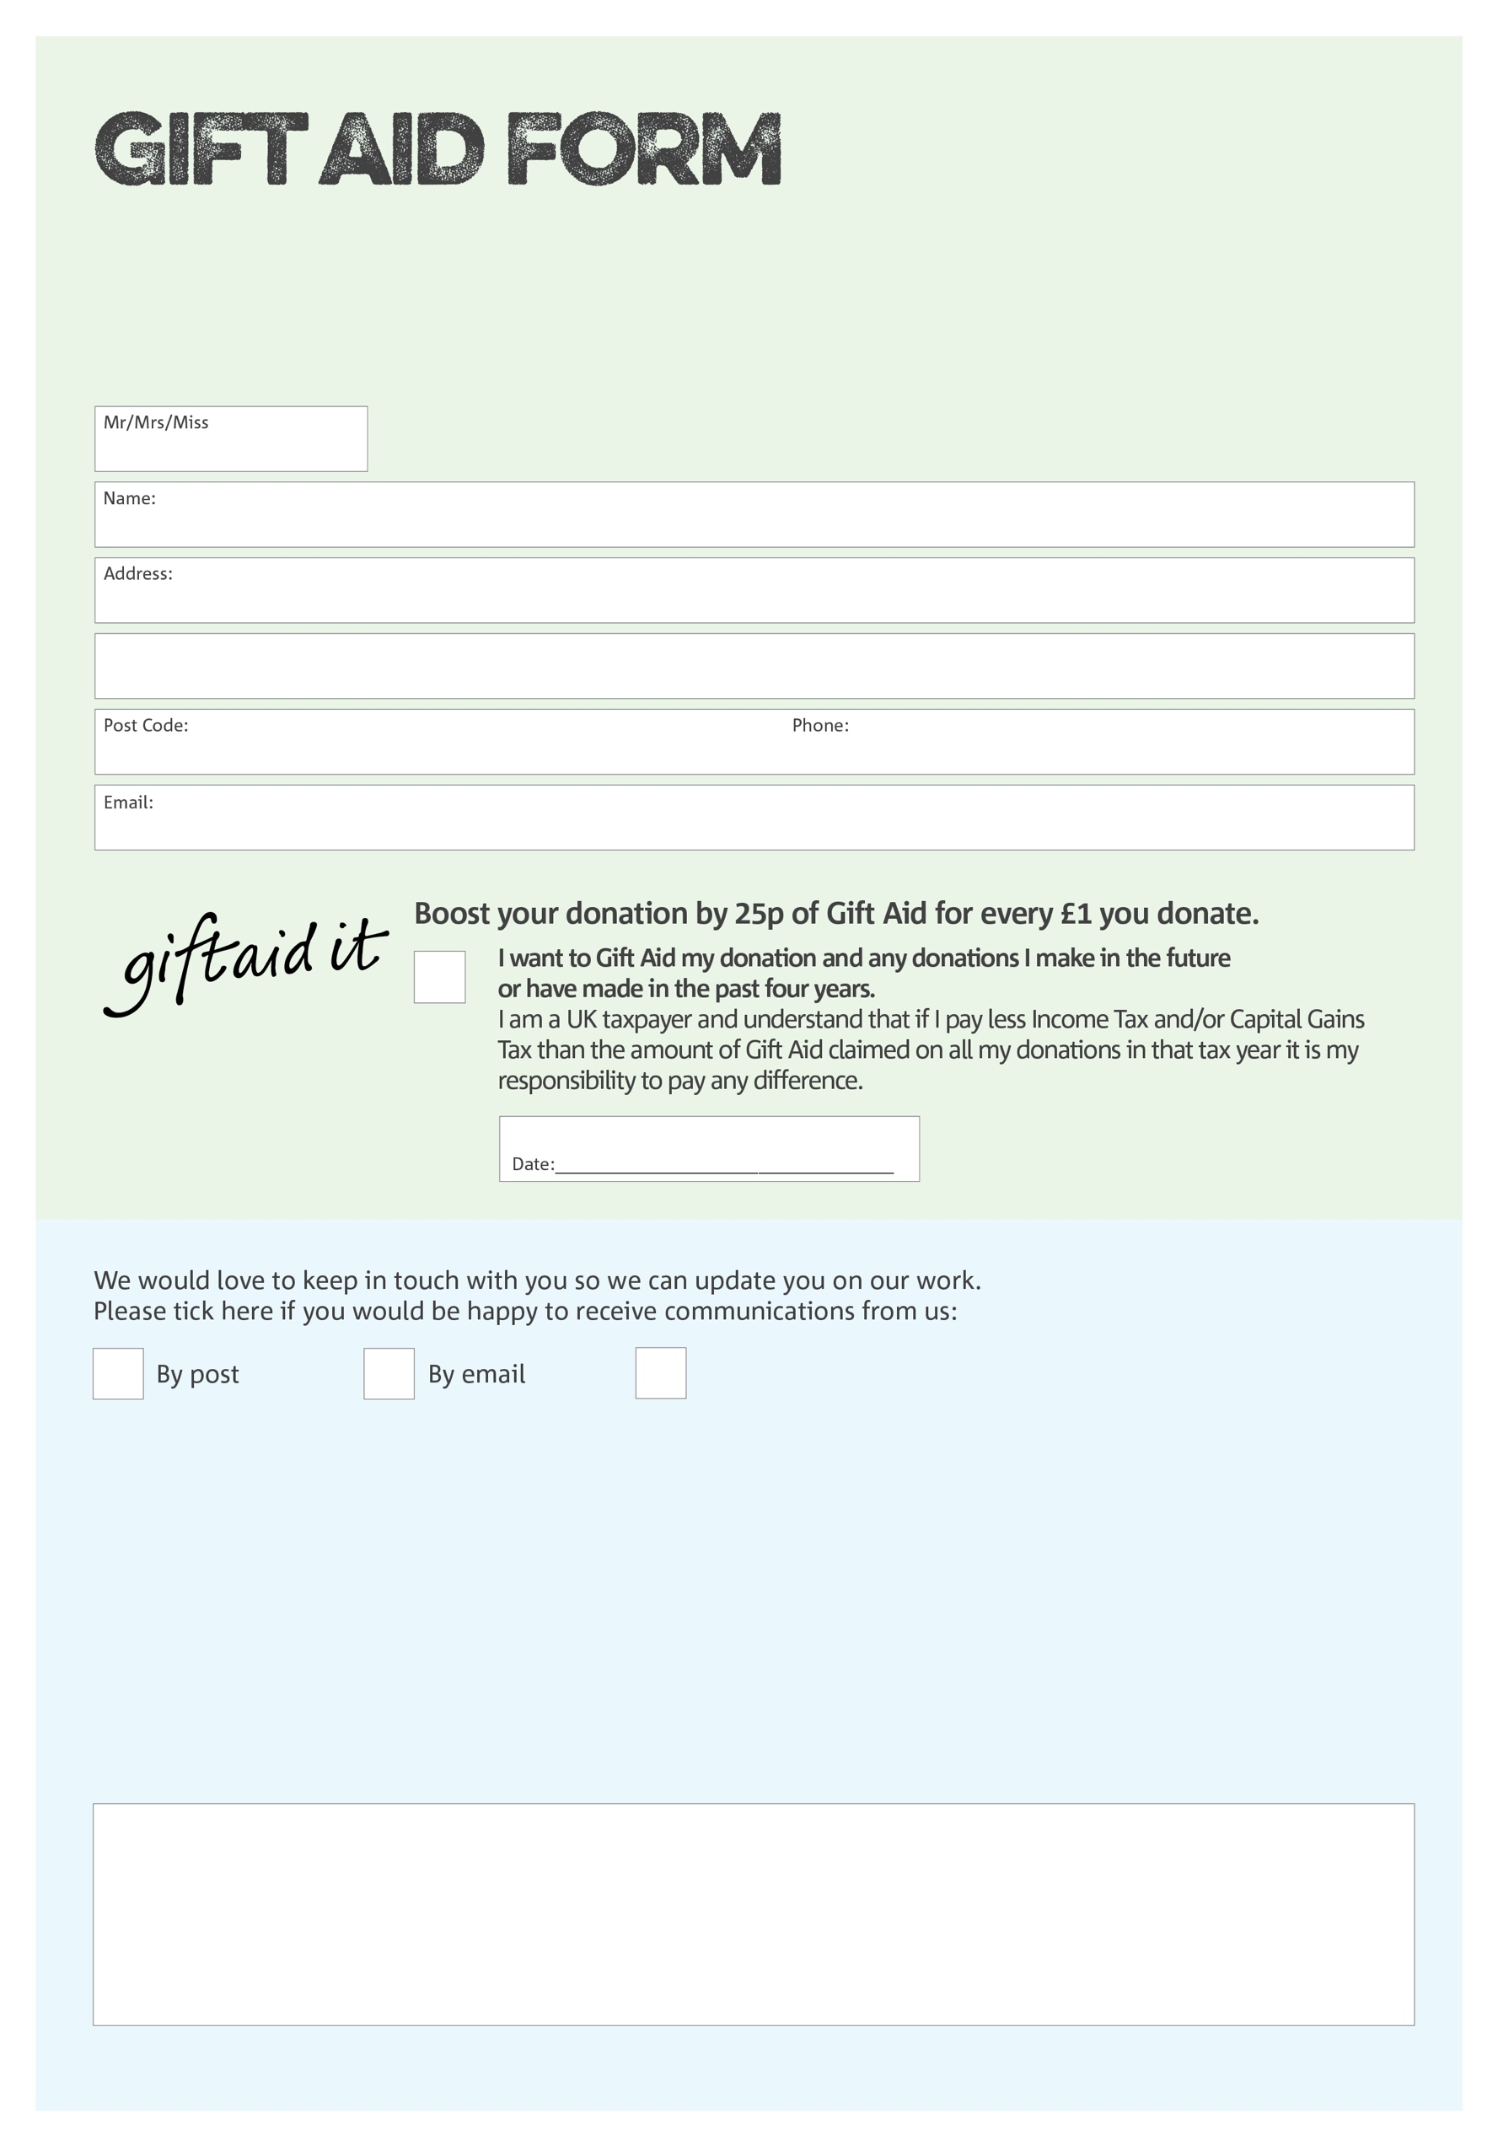

By filling in this form Wrexham Foodbank will receive an extra 25p for every £1 you give at no extra cost to you. Thank you!

Charity Number 1162262. Registered in June 2015

You can change your preferences any time by contacting us on 07538547971 or emailing us at

info@wrexham.foodbank.org.uk

I do not wish to receive future communications from Wrexham Foodbank

**Data protection**

Wrexham Foodbank is committed to protecting your privacy and will process your personal data in accordance with the Data Protection Act 1998. Wrexham Foodbank collects information to keep in touch with you and supply you with information relating to our work. Wrexham Foodbank will never sell or pass your details to anyone who isn’t directly working on our behalf.

We would love to know why you have chosen to donate to Wrexham Foodbank. If you would like to share your motivation let us know below: