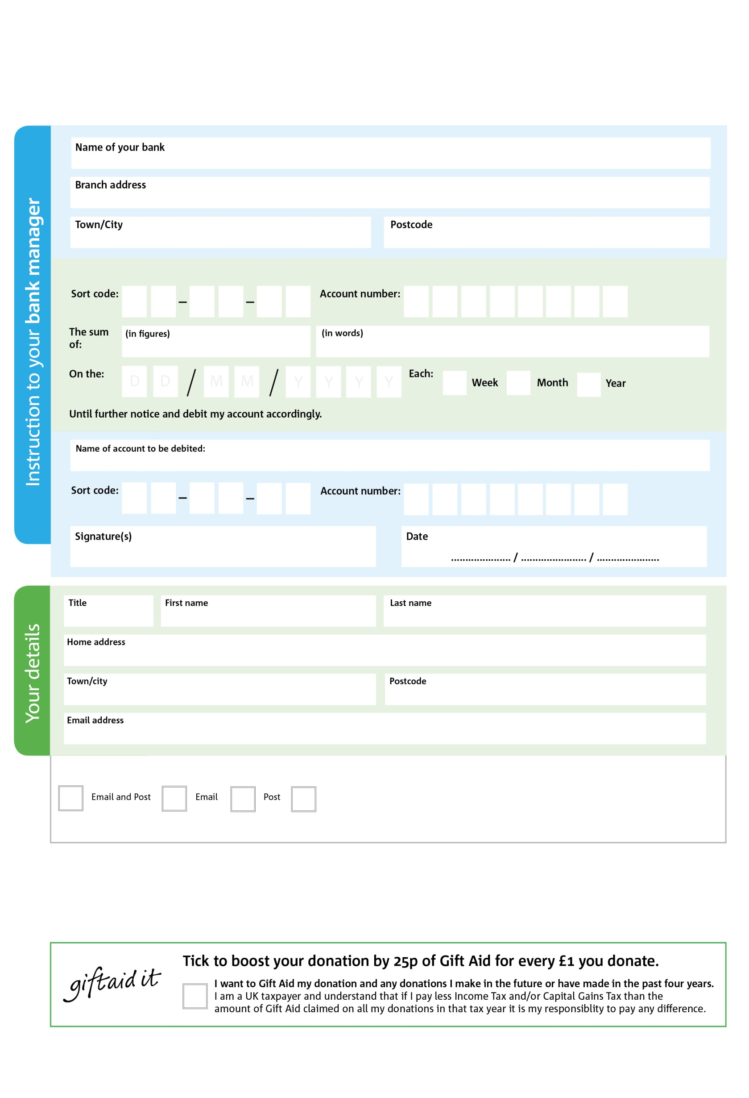

POSTAL ADDRESS: Wrexham Foodbank,Unit 1A, Puleston Industrial Estate, Ruabon Road, Wrexham, LL13 7RF

Reg. Charity No: 116262 | Reg. in England & Wales

1

V

0

V

0

V

7

V

1

V

2

V

0

V

0

V

**Please pass this form onto the foodbank, using the foodbank’s address at the bottom, who will save a copy for their records.   
They will then send it onto your named bank or building society.**

3

7

1

0

0

6

We would love to keep you up to date with information about Wrexham Foodbank. Please tick your preference:

You can change your preferences any time by contacting us on 07538547971 or emailing us at info@wrexham.foodbank.org.uk.

I do not wish to receive future communications from Wrexham Foodbank

Please pay Wrexham Foodbank,

**Data protection**

*'Wrexham Foodbank is committed to protecting your privacy and will process your personal data in accordance with current Data Protection legislation. Wrexham Foodbank collects information to keep in touch with you and supply you with information relating to our work. To unsubscribe from our newsletter, send a message to the email address above with the word unsubscribe in the subject line. A full data privacy statement for financial donors is available from the foodbank on request.’*

**Standing Order Mandate**

**wrexham.foodbank.org.uk**

You can change your preferences any time by contacting us on XXXXXXXXXXX or emailing us at XXXX@XXXXXXXXXX.foodbank.org.uk

I do not wish to receive future communications from XXXXXX Foodbank